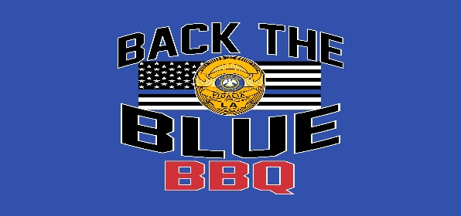

LOUISIANA STATE CHAMPIONSHIP, KCBS SANCTIONED
VPD-BACK THE BLUE BBQ COMPETITION TEAM APPLICATION
October 28-29, 2022

Team Name: ______________________________________________

Pitmaster: ________________________________________________ KCBS #_____________

Address: _________________________________________________

Telephone: ________________________________________________

E-Mail Address: _____________________________________________

Entry Fee: PLEASE MAKE PAYABLE TO: VIDALIA POLICE DEPARTMENT/BACK THE BLUE BBQ

______ $225 Entry Fee – water/electricity and first night rv team pad included

______ $ 30 Additional RV Pad per night-OPTIONAL – Payable to Riverview RV Park

______ $ 30 Additional Night each pad per night-OPTIONAL – Payable to Riverview RV Park

$_____ Total Payable to Vidalia Police Dept./Back the Blue BBQ (Please add team name in check’s
Memo)

$_____ Total payable to Riverview RV Park

OTHER INFORMATION NEEDED FOR RV PARK:

Length of trailer/motorhome ____________ # of Slides __________
Please check one: _____5th Wheel _____Trailer _____Motor Home
_____Class (A, B, C)

WAIVER OF LIABILITY

The Vidalia Police Department and Back the Blue BBQ Competition, including its officers, sponsors and/or associates and the contestants, including parents, and/or legal representatives, agree that the Vidalia Police Department and Back The Blue BBQ Competition, will in no case be responsible for any loss, damage, or injury regardless of how much loss, damage or injury is occasioned, and indemnify and save harmless the Vidalia Police Department and Back the Blue BBQ Competition, The Riverview RV Park &
Resort from any and all claims, suits, and/or judgments including the cost for defense or and such claim and/or suit such claim and/or suit by the Vidalia Police Department Back the Blue BBQ Competition, The River View RV Park & Resort brought by anyone as result of any loss, damage, or injury to any person or property, occasioned by any action or inaction of contestant, either solely or in conjunction with the Vidalia Police Department Back the Blue BBQ Competition and the River View RV Park & Resort. Further, I hereby grant full permission to the Vidalia Police Department Back the Blue BBQ Competition and/or agents authorized by them, to use any photographs, videotapes, motion pictures, recordings or any other record of the event for any legitimate purpose. I have read and agree to abide by the rules governing the BBQ cook-off.

Signature:

_______________________________________________________ Date:_____________

PLEASE RETURN APPLICATION AND FEES TO:

VIDALIA POLICE DEPARTMENT
ATTN
202 VERNON STEVENS BLVD.
VIDALIA, LA 71373

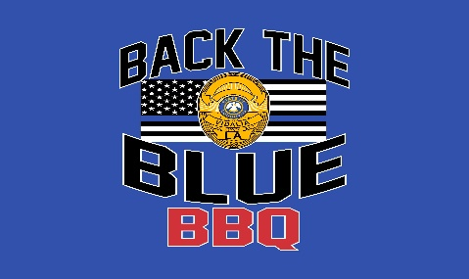

VPD “Back the Blue” BBQ Competition
October 28-29, 2022

Dear Pitmaster,

Do you grill a top-notch porkbutt or fantastic pork ribs – or maybe you’re known for serving up the best grilled chicken in town or smoking a beef brisket that’s simply out of this world delicious?

Whatever your style, you’re invited to bring a team and join in the grilling challenge at the Vidalia Police Department’s “Back the Blue” BBQ Competition October 28-29. Participation in this KCBS (Kansas City Barbecue Society) sanctioned cook-off could lead you and your team to a Louisiana State Championship!

In addition, for the teams that wish to participate, a Louisiana seafood cook-off will be featured on Friday evening, with the Louisiana Seafood Promotion Marketing Board providing the seafood. Following the seafood judging, the teams and judges will be invited to partake of the seafood cuisine.

The event will be held at the River View RV Park located on the bank of the Mississippi River, 800 Martin Luther King Ave., Vidalia. This site is well known for offering all the amenities one could need, as well as being centrally located to shopping and touring venues in the Miss-Lou area.

Ann Westmoreland Goeggle, who has many years experience working with KCBS sanctioned barbecues, is serving as the event’s volunteer organizer, and hopes to welcome you and your friends/family to this exciting weekend.

We’re looking forward to a weekend filled with great food and friendly grilling competition and we hope that you and your team can join us! If you’re interested, there is a participant application attached to this letter. Should you have any questions whatsoever, please contact Sheila McFarland at the Vidalia Police Department, 318-336-5254 or Ann W. Goeggle at 601-421-9222.

Hoping to see you soon!

Sincerely,

Joey, Merrill, Chief of Police
Vidalia Police Department

